ENGLISH ASSESSMENT

Name: Date:

INSTRUCTIONS:
1. This exam is 2 hours long; there are 7 open- or closed-ended questions, beside a paper attached.
2. Open-ended questions should be answered in Portuguese (except question 3.b), in the space provided below the question header.
3. Printed dictionary is allowed, but you cannot lend or borrow dictionaries to/from other candidates.
4. Do not come to the front of the class when the exam is over; we will pick up your exam from you.
Good luck!

QUESTIONS

- Esta questão foi anulada
One study claimed that “The drug cured 1/3 of the infected mice, another 1/3 were not affected by the treatment, and the third mouse got away.” How many mice in the experiment? (0.5 point)
- Three
- Six
- Nine
- Countless

- One of these sentences is correct:
- 1st: The erythrocytes, which are in the blood, contain hemoglobin.
- 2nd: The erythrocytes that are in the blood contain hemoglobin.
  - Which one? (0.5 point)

  - Why? (0.5 point)

- An article brings one phrase with double meaning: “After incubating at 30 degrees Celsius, we examined the Petri plates.”
  - With this wording, what is the meaning of the sentence? (0.5 point)

  - Rewrite the sentence IN ENGLISH so that it presents the appropriate meaning. (0.5 point)

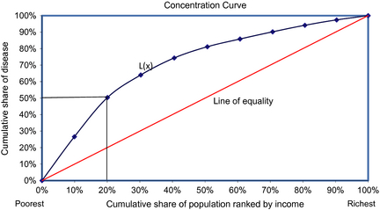
Figure legend: Concentration curve. Notes: x-axis represents the cumulative proportion of individuals by income, beginning with the lowest and ending with the highest income and the y-axis represents the cumulative total proportion of ill-health. The relative concentration index is defined as twice the area between the concentration curve, L(x), and the line of equality. In the case where there is no income-related inequality, the relative concentration index is zero. The farther the concentration curve lies from the line of equality, the greater the degree of inequality.
- According to the abovementioned hypothetical graph cited by Ravaghi et al. (Community Dentistry and Oral Epidemiology, Volume 41, Issue 6, pages 490–498, December 2013), one can affirm that: (1.0 point)
- 20% of the disease is concentrated among the poorest 20%
- 20% of the disease is concentrated among the poorest 50%
- 50% of the disease is concentrated among the poorest 20%
- 50% of the disease is concentrated among the poorest 50%

- Now interpret the real outcomes of the study by Ravaghi et al. (2013), according to the graph below: (1.5 point)
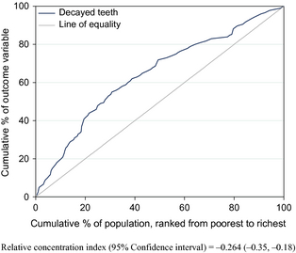

- One of the research areas of the UFG Graduate Program in Dentistry is "Performance of dental materials." Based on the paper from Watson et al (attached), please answer the questions below:
  - What does influence the longevity of restorations? (0.5 point)

  - What are the issues that suppliers of dental equipment face? (0.5 point)

  - What should be the goal of innovation of dental materials, according to the workshop discussed in this article? (0.5 point)

  - Authors mention that caries is ubiquitous. What does that mean? (0.5 point)

  - The innovation of dental materials has been transferred from universities to industries. What are the causes? (0.5 point)

- The abstract below refers to an editorial by Emrick and Gullard [J Dent Res 92(12):1053-1055, 2013]. Please translate it to Portuguese. (2.5 point)
The integration of research into dental education is necessary to ensure that evidence-based practice reaches the clinical setting and that dentistry remains a scientifically driven health profession. Consequently, dental accreditation standards in the United States and Canada require dental schools to integrate research components into curricula. Organizations (e.g., NIDCR, ADEA, AADR, IADR, and NSRG) provide some opportunities for dental students to experience research. Assessment of the integration of research into dental curricula suggests that US students are interested in learning and utilizing evidence-based practice, but lack adequate time for research participation. Records show limited student involvement in research organizations internationally (i.e., AADR and IADR). Vague accreditation standards and limited research opportunities outside of dental schools may be barriers. We lack an understanding of the status of integration of research into dental curricula internationally, but predict that similar issues exist. We propose that dental institutions consider implementing the following: (1) curriculum components to assess the use of evidence-based practice, (2) faculty and student seminars for discussing evidence-based practice, (3) subsidization of student membership in dental research organizations (e.g., AADR and IADR), and (4) sponsorship of students as institutional representatives at annual research meetings (e.g., IADR, AADR, ADA, and ADEA meetings), with subsequent school-wide dissemination of knowledge attained from attendance.

